- Introduction
  - Overview
To create a book cover for our Institution
  - purpose
To reach the students with the invitation
- Problem definition and design thinking
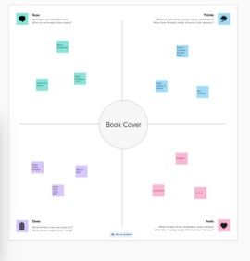
- Empathy

- Brainstorm
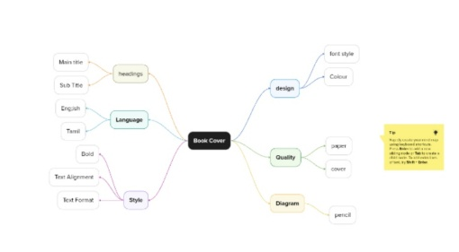

- Result
- Advantages and disadvantage
Its easy to reach the people at any time
It’s was so easy
5. Applications
It can gather all people
- Conclusion
Successfully created book cover using the canva app

